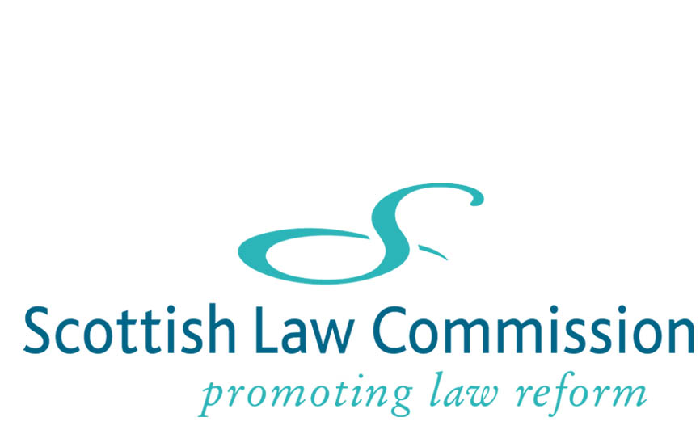

RESPONSE FORM
CONSULTATION PAPER ON PUBLIC AND CHARITABLE TRUSTS: AMALGAMATION OF FUNCTIONS AND COMMON INVESTMENT FUNDS

We hope that by using this form it will be easier for you to respond to the proposals or questions set out in the Consultation Paper. The form reproduces the proposals/questions as summarised at the end of the paper and allows you to enter comments in a box after each one. At the end of the form, there is also space for any general comments you may have.

Please ensure that, prior to submitting your comments, you read notes 1-2 on page ii of the Consultation Paper.

In order to access any box for comments, press the shortcut key F11 and it will take you to the next box you wish to enter text into. If you are commenting on only a few of the proposals, continue using F11 until you arrive at the box you wish to access. To return to a previous box press Ctrl+Page Up or press Ctrl+Home to return to the beginning of the form.

Please save the completed response form to your own system as a Word document and send it as an email attachment to info@scotlawcom.gsi.gov.uk. If you prefer you can send the form by post to Scottish Law Commission, 140 Causewayside, Edinburgh EH9 1PR.

Name:

«InsertTextHere»

Organisation:

«InsertTextHere»

Address:

«InsertTextHere»

Email address:

«InsertTextHere»

Summary of Proposals

1. Should Scots law provide a statutory facility to enable charitable and other public trusts to amalgamate those administrative functions identified in paragraph 11(i) and (ii)? Should any other matters be included?
(Para 17)
Comments on Proposal 1
«InsertTextHere»

2. Are the limitations on any such facility set out in paragraph 12 appropriate?
(Para 17)
Comments on Proposal 2
«InsertTextHere»

3. Would it be helpful to have statutory styles to assist in drafting formal agreements to amalgamate functions or would this need be better met in other ways, for example by the inclusion of suitable styles in published style books?
(Para 17)
Comments on Proposal 3
«InsertTextHere»

4. For the reasons set out in paragraph 13 it should be possible for trusts to make use of the new facility notwithstanding any express provision in the trust deed.
(Para 17)
Comments on Proposal 4
«InsertTextHere»

5. (a) For the reasons set out in paragraph 13 the facility should be available without any application to the court or OSCR.

(b) Should OSCR nevertheless have a discretionary power to veto or cancel any such amalgamation in the event that a complaint is made by an interested party?
(c) If so, should a time limit, for example four weeks from the date when the amalgamation takes effect, be imposed for the making of such a complaint?
(d) Would the appropriate criterion for the exercise of such a power of veto or cancellation be that the proposed amalgamation is, in the opinion of OSCR, contrary to the interests of one or more of the trusts involved (as we propose in paragraph 14)? Or would any alternative formulation be more appropriate?
(Para 17)
Comments on Proposal 5
«InsertTextHere»

6. Do you consider that there would be a demand in practice for Common Investment Funds (CIFs) and Common Deposit Funds (CDFs) established under Scots law? If so, do you have in mind the position of those interested in managing CIFs/CDFs or of those interested in investing in them, or both? Any evidence you have in support of your answer would be welcomed, however general or specific it may be.
(Para 22)
Comments on Proposal 6
«InsertTextHere»

7. Subject to satisfactory evidence as to the likely demand in practice, it would be desirable to permit CIFs and CDFs to be set up under Scots law. This would have the effect of making the CIF and CDF regime uniform across the UK.
(Para 25)
Comments on Proposal 7
«InsertTextHere»

8. Do you agree with our analysis of the likely fiscal and regulatory liabilities arising on the creation of Scottish CIFs and CDFs? If you disagree, what such liabilities do you foresee arising?
(Para 25)
Comments on Proposal 8
«InsertTextHere»

9. If CIFs and CDFs were to be established under Scots law, would UK charities established outwith Scotland need to satisfy the Scots law charity test in order to be eligible to invest? If so, could this be achieved without formal registration as a Scottish charity?
(Para 26)
Comments on Proposal 9
«InsertTextHere»

General Comments
«InsertTextHere»

Thank you for taking the time to respond to this Consultation Paper. Your comments are appreciated and will be taken into consideration when preparing a report containing our final recommendations.

