
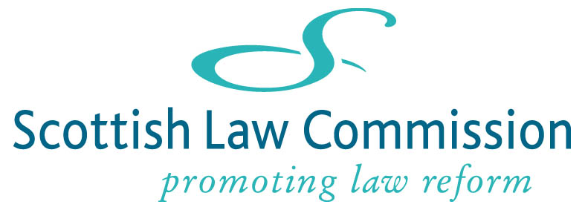

Draft Insurable Interest Bill
June 2018
Response form

This optional response form is provided for consultees’ convenience in responding to the questions on the draft bill and its impact.
We are happy to receive simple yes/no answers but more detailed comments would also be helpful. You do not have to respond to every question. Answers are not limited in length (the box should expand, if necessary, as you type).
We invite responses by 31 October 2018.
Please send your completed form by email to:
commercialandcommon@lawcommission.gov.uk

Privacy Notice
Under the General Data Protection Regulations (May 2018), the Law Commissions must state the lawful bases for processing personal data. The Commissions have a statutory function, stated in the 1965 Act, to receive and consider any proposals for the reform of the law which may be made or referred to us. This need to consult widely requires us to process personal data in order for us to meet our statutory functions as well as to perform a task, namely reform of the law, which is in the public interest. We therefore rely on the following lawful bases:
(c) Legal obligation: processing is necessary for compliance with a legal obligation to which the controller is subject
(e) Public task: processing is necessary for the performance of a task carried out in the public interest or in the exercise of official authority vested in the controller.
Law Commission projects are usually lengthy and often the same area of law will be considered on more than one occasion. The Commissions will, therefore retain personal data in line with our retention and deletion policies, via hard copy filing and electronic filing, and, in the case of the Law Commission of England and Wales, a bespoke stakeholder management database, unless we are asked to do otherwise. We will only use personal data for the purposes outlined above.

Freedom of information
We may publish or disclose information you provide us in response to our papers, including personal information. For example, we may publish an extract of your response in our publications, or publish the response in its entirety. We may also share any responses received with Government. Additionally, we may be required to disclose the information, such as in accordance with the Freedom of Information Act 2000 and the Freedom of Information (Scotland) Act 2002. If you want information that you provide to be treated as confidential please contact us first, but we cannot give an assurance that confidentiality can be maintained in all circumstances. An automatic disclaimer generated by your IT system will not be regarded as binding on the Law Commissions. The Law Commissions will process your personal data in accordance with the General Data Protection Regulations, which came into force in May 2018.
Any concerns about the contents of this Privacy Notice can be directed to: enquiries@lawcommission.gov.uk.

How to complete this form
Please SAVE A COPY OF THIS DOCUMENT before you begin to enter your responses. Once you have completed your response, please save the document and email it to commercialandcommon@lawcommission. gov.uk.
Your details
Name
Organisation
Type of response | Personal response  Response on behalf of above named organisation
Email address
Telephone number
If you want information that you provide to be treated as confidential, please explain to us why you regard the information as confidential. As explained above, we will take full account of your explanation but cannot give an assurance that confidentiality can be maintained in all circumstances.

Chapter 2: Explaining the draft Insurable Interest Bill
Q1 | - Do consultees have any further comments on clause 1 of the draft Bill (Definitions)?  Yes No Other
Q2 | Do consultees consider that the updated drafting in clause 2(3)(b) is sufficiently flexible to cover all relevant group schemes?  Yes No Other

Q3 | Do consultees consider that it is useful to provide that the insured has an insurable interest where the policy is for the benefit of the life insured or their nominee?  Yes No Other
Q4 | Do consultees envisage a situation in which an insured should not have insurable interest in these circumstances, or where this clause could be abused?  Yes No Other

Q5 | Do consultees consider that clause 2(4) is appropriately framed to cater for all the types of trust commonly used?  Yes No Other
Q6 | Do insurance contracts cater for “mid-term beneficiaries” under the current law? If so, how?  Yes No Other
Q7 | Do consultees agree that clause 2(5) caters adequately for “mid-term beneficiaries”?  Yes No Other
Q8 | The words in brackets at the end of clause 2(5) are intended to cover lives not yet in existence, such as future grandchildren. Do consultees consider that those words are required?
 | Yes No Other

Q9 | Do consultees think it is necessary to explicitly exclude marine insurance contracts, given that the draft Bill is now limited to life-related insurance contracts?  Yes No Other
Q10 | Do consultees agree that it is necessary to retain section 1 and section 4 of the Life Assurance Act 1774 in order to cover non-life insurances to which that Act applies? Can consultees give any examples of insurances which would be caught?  Yes No Other

Chapter 3: The impact of our proposals
Q11 | Do consultees agree that our proposals for reform, as set out in the draft Bill, would make the insurance market work better?
 | Yes No Other
Q12 | We believe that our proposals will allow for the development of new products in the UK insurance market, and will remove the commercial disadvantages potentially suffered by insurers who currently comply with the law. Do consultees agree? Do consultees foresee any other benefits?  Yes No Other
Q13 | Are consultees able to give any indication of the monetary value of these, or any such, benefits?
 | Yes No Other
Q14 | We believe that the costs to business of such reform would be minimal. We welcome evidence as to the potential costs.

