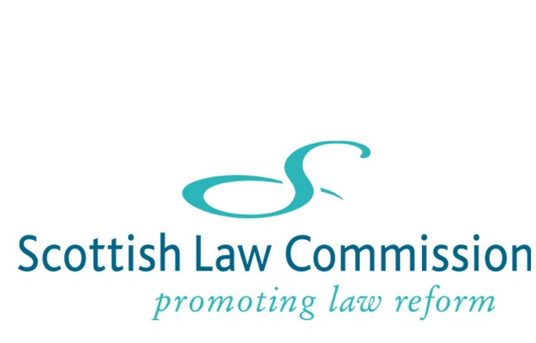

REGISTER OF COMMISSIONERS' INTERESTS
(AS AT MAY 2024)
Name | Remuneration | Other roles | Contracts | Election Expenses  [none of the Commissioners is elected to the Commission] | Houses, Land and Buildings | Interest in Shares and Securities | Gifts and Hospitality | Non-financial interests | Close family members
The Rt Hon Lady Paton | Senator of the College of Justice  Sole author of McEwan & Paton, Damages for Personal Injuries in Scotland (2nd edition), royalties paid on sales. | Nil | Nil | n/a | Nil | Shares in Scot Mort Inv TST Ord; Findlay Park FDS American USD Dis; Natixis Inv Mngrs Loomis Sayles US Equity; Vanguard Funds plc S & P 500 UCITS ETF USD DIS; Maitland Instl SVC MI Select Mngrs Bond Instl; American W1 ACC | Nil | Member, Faculty of Advocates  Assessor to the Chancellor of Napier University | Nil
David Bartos | Fees for arbitrator work from HuntADR Travel Arbitration under the ABTA arbitration scheme  Co-author (with Hew R Dundas) of Dundas & Bartos on the Arbitration (Scotland) Act 2010 (2nd ed, 2014), royalties paid on sales  Co-author (with the late Prof M Meston) of Bartos & Meston on the Succession (Scotland) Act 1964 (2nd ed, 2015), royalties paid on sales  Fees for advocacy work carried out prior to appointment when practising as member of the Faculty of Advocates  Fees for work carried out prior to appointment when serving as a Tribunal chairperson in the Housing and Property Chamber of the First -tier Tribunal for Scotland. The last payment was made in or before 2021. | Nil | Nil | n/a | Nil | Nil | Nil | Member, Faculty of Advocates  Member, ABTA Panel of Arbitrators  Fellow, Chartered Institute of Arbitrators | Nil
Professor Gillian Black | Royalties from sales of academic publications, both directly from the publisher and via ALCS  Texts for which I receive royalties from publishers are:  Woolman and Black, Woolman on Contract  Black (ed) Business Law in Scotland  Black, Publicity Rights and Image: Exploitation and Legal Control  I deliver annual CPD training via Edinburgh Law Seminars  Director of Callum Black Limited  Potential for ad hoc fees from consulting work as Linlithgow Pursuivant Extraordinary  Potential for ad hoc fees from consulting work as Academic Associate Member of Harcourt Chambers. | Nil | Nil | n/a | Nil | Nil | Nil | Professor of Scots Private Law, University of Edinburgh (on leave to the Scottish Law Commission)  Non-practising Solicitor  Member of the Heraldry Society of Scotland and the Royal Celtic Society.  Council Member of the Stair Society  Fellow of the Society of Antiquaries of Scotland  Trustee of the Lord Lyon Society, SC050846  Visiting Professor at Edinburgh Napier University  Trustee of the Edinburgh Law Review Trust, SC027403 | Nil
Professor Frankie McCarthy | Co-author (with Anne Griffiths and David Fotheringham) on Family Law (4th ed, 2015), royalties paid on sales  Author of Succession Law (EUP Law Essentials series, 2013), royalties paid on sales | Nil | Nil | n/a | Nil | Nil | Nil | Professor of Private Law, University of Glasgow (on leave to the Scottish Law Commission)  Member, Society of Legal Scholars | Nil
Ann Stewart | Lead author of Conveyancing Practice in Scotland (8th Edition, 2020); royalties paid on sales from publisher and ALCS. | Professional Support Lawyer at Shepherd and Wedderburn LLP (part-time 2½ days a week) | Nil | N/A | Nil | Nil | Nil | Member, Law Society of Scotland;  Member, LSS Property Law Committee;  Member, LSS Property and Land Law Reform Committee;  Member Property Standardisation Group.  Currently a member of two Scottish Property Federation Working Groups – Real Estate and Building Regulation and Environmental, but planning on resigning from these. | Nil

